**Sir Syed University Of Engineering & Technology**



**PROJECT REPORT**

**SUBMITTED BY : ASIM ZULFIQAR (2015-EE-129)**

**SYED HASAN (2015-EE-121)**

**MUHAMMAD QAMAR (2015-EE-131)**

**DEPARTMENT : ELECTRONICS**

**TITLE : RFID BASED ATTENDANCE SYSTEM**

**SECTION : EE4C**

**SUBMITTED TO : SIR JAWAD BHATTI**

**INTRODUCTION**

Nowadays, attendance system in schools and colleges are generally based on paper. So sometimes this process causes errors and also takes more time. So this project uses RFID technology to make a note of every student entering into the classroom and also to calculate the time resides in the class. In this proposed system, every student is allotted with an RFID tag. The process of attendance can be done by placing the card near the RFID reader and not only this but we have introduced some more functions in this project.

**What is RFID ?**

The term RFID (radio frequency identification) is a one type of electronic device includes a small antenna and a chip. This device is used to transmit the information like persons, animals, books or any stuff between reader and RFID tag using radio frequency electromagnetic fields. It is capable of carrying 2k bytes of data. There are different kinds of RFID systems in the market, which consist of an antenna, a transponder and a transceiver. Some types of tags can be located close to the RFID reader and some tags can be located far from the reader. The operating frequency ranges of these devices mainly include low, mid and high ranges. The low frequency range is from 30kHz to 500kHz, mid frequency range is from 900kHz to 1500kHz and high frequency range is 2.4kHz to 2.5kHz.

RFID (radio frequency identification) is designed to serve as the Purpose of barcode scanner or a magnetic strip on the back of the ATM card. It creates unique identifier for that object and just as a bar code or magnetic strip it must be scanned to get the information RFID must be scanned to retrieve the information.

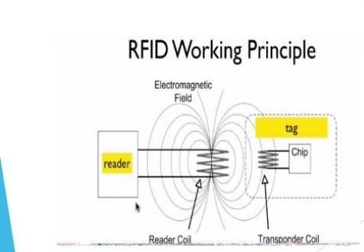

**How Does RFID Work?**

RFID belongs to a group of technologies referred to as Automatic Identification and Data Capture (AIDC). AIDC methods automatically identify objects, collect data about them, and enter those data directly into computer systems with little or no human intervention.  
RFID methods utilize radio waves to accomplish this. At a simple level, RFID systems consist of three components: an RFID tag or smart label, an RFID reader, and an antenna. RFID tags contain an integrated circuit and an antenna, which is used to transmit data to the RFID reader (also called an interrogator). The reader then converts the radio waves to a more usable form of data. Information collected from the tags is then transferred through a communications interface to a host computer system, where the data can be stored in a database and analyzed at a later time.

**CIRCUIT DIAGRAM**

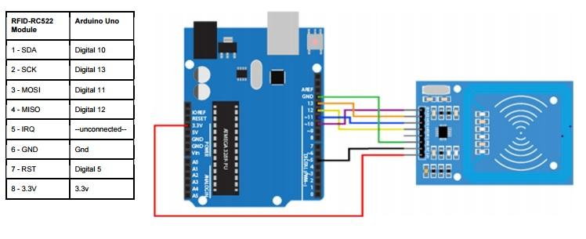

**WORKING**

In this project we have used RFID reader, RFID tags, arduino UNO, a server based database and C#. The user interface is created on C# and on the first page we have provided four options i.e. Login, Student, about and exit. The Login option is for the management from where you can login and access the data by providing the login details i.e. username and password. In the Student option, which will be opened always, the user interface will always be opened and whenever student will scan his card the attendance will be marked and will be saved in the database with time and the time table will be showing there. In the about section there is detail about the project and by clicking the exit button you can quit the application. By logging in management can upload data, marks, assignment, and fee notification and can view the same data, can search the data. The assignment and the fee notification will be emailed. We have created separate window for everything and your PC must be connected with the internet and the RFID while using the application as the application is not accessible until the serial port is open or in simple words until the arduino is not connected. As we have mentioned above that every RFID tag has unique number so whenever student will scan his card the RFID tag number will be send to the database and that unique tag number will be identity of every single student.

You will have to save the data of student i.e. his name etc before allowing him to mark attendance.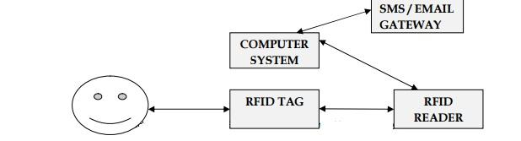

**BLOCK DIAGRAM**

Start



RFID scanner







Is student 

Marked?

YES



Mark leaving Already Marked

Time



Display leaving

Note 



END

**SNAPSHOTS**

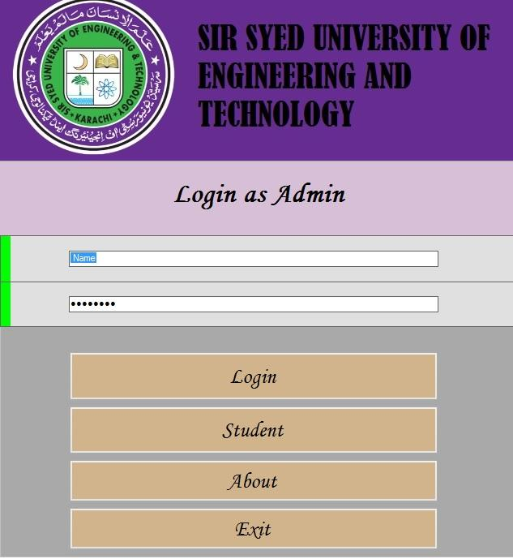 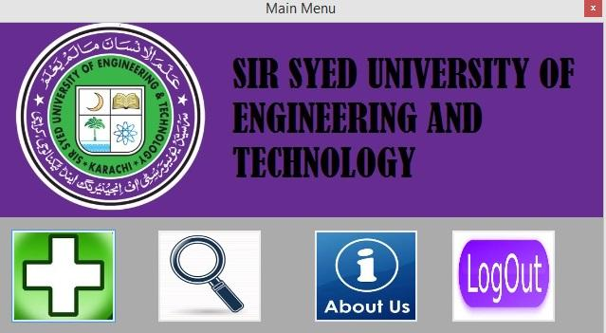

**FIG : MAIN PAGE & MAIN MENU**

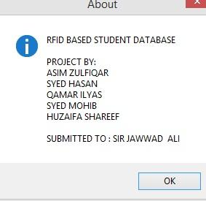 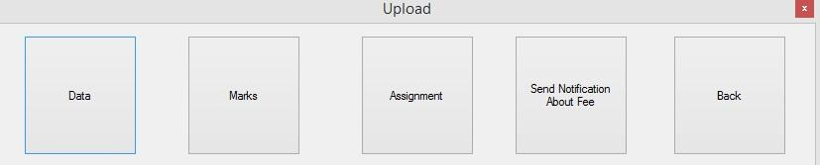

**FIG : ABOUT & UPLOAD WINDOW**

**CONCLUSION**

This project will help any institute to manage their data and this can be made better by adding some new options and components like you can add the GSM and send SMS to the parent of the student whenever he his card is scanned for the attendance and you may add many other things. You can add keypad and can ask for the password whenever the card is scanned and you can add the separate windows for every student and you can allow them to see that window. You can show the results or data on LCD for better presentation.